Project Design Phase
Solution Architecture

Date | 19 September 2026
Student ID | 23NU1A4429
Project Name | Automated Network Request Management in ServiceNow
Maximum Marks | 4 Marks

Solution Architecture:
Solution architecture is the foundational framework that bridges enterprise business friction and automated cloud technology solutions. For this system, the architecture maps out a highly secure, transaction-validated, and transparent data path. Its core structural goals include:
• Solving Existing Business Friction: Eliminating manual email routing delays, clerical copy-paste bottlenecks, and coordination anxieties during department space relocations.
• Providing Stakeholder Clarity: Mapping exact data relationships, UI enforcement filters, approval gates, and data storage boundaries for clear engineering reference.
• Defining System Requirements: Outlining the execution timeline across frontend web portal objects, backend low-code workflow studio components, and secure relational database states.
• Enforcing Technical Standards: Giving exact specifications regarding session validation, security access control layers, data integrity checks, and direct persistence pipelines.

Solution Architecture and Data Flow Diagram Below is the end-to-end cloud-native architecture mapping how user intake form inputs transform into structured, transaction-verified operational records within the persistent ledger.
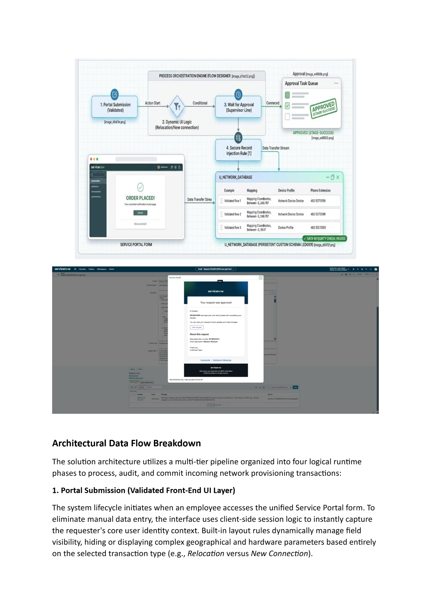
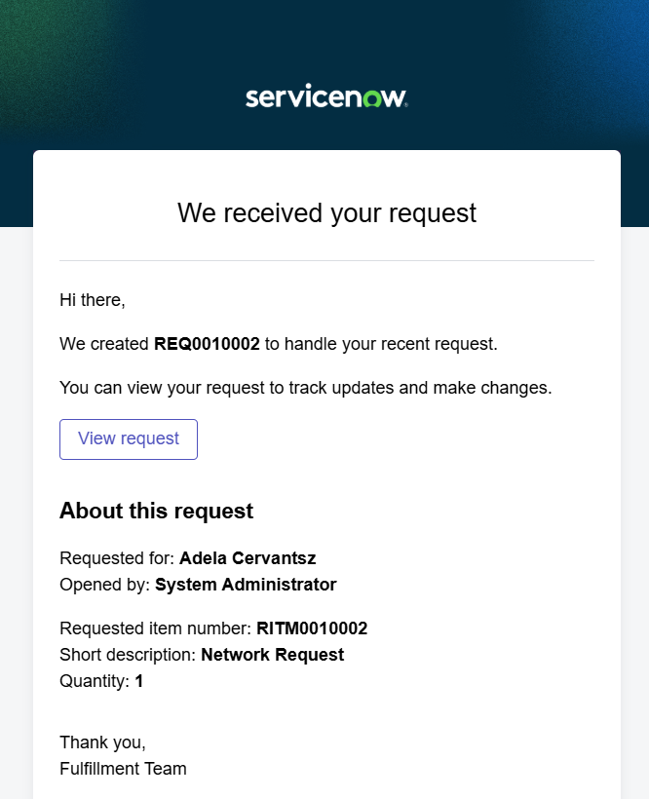

Architectural Data Flow Breakdown
The solution architecture utilizes a multi-tier pipeline organized into four logical runtime phases to process, audit, and commit incoming network provisioning transactions:
1. Portal Submission (Validated Front-End UI Layer)
The system lifecycle initiates when an employee accesses the unified Service Portal form. To eliminate manual data entry, the interface uses client-side session logic to instantly capture the requester's core user identity context. Built-in layout rules dynamically manage field visibility, hiding or displaying complex geographical and hardware parameters based entirely on the selected transaction type (e.g., Relocation versus New Connection).

2. Process Orchestration Engine (Cloud Workflow Studio)
Once a verified form is submitted, a runtime action instantly hands the payload over to the platform's Flow Designer Engine. This cloud layer acts as the centralized operational controller, decoupling basic frontend entries from the backend database layer to guarantee system scalability and protect baseline system runtime availability.

3. Multi-Stage Approval Gate (Supervisor Task Queue)
The orchestration engine evaluates transaction properties against organizational routing criteria and creates an active entry inside the targeted manager's Approval Task Queue. The request sits at this operational milestone while the platform generates and sends real-time system notifications and email links. This ensures that no database write occurs without authorized, authenticated sign-off.

4. Secure Record Injection Rule (Data Integrity Ledger Storage)
Upon a successful approval action, the system moves into its final execution state. Instead of placing generic logs into common system tables, a dedicated server-side injection script triggers an automated data integrity sanity check. Once passed, clean row records are written directly into the custom enterprise relational database schema: u_network_database. The portal form then

